Docking Parish Council Minutes
Clerk: Annalisa Dovey
Email: clerk@dockingparishcouncil.gov.uk

Location: Docking Ripper Hall
Date : Monday 2nd June
Time: 6.30pm | Coffee and biscuits
7.00pm | Meeting opens
Present: Cllr David Wroth (Chair), Cllr Nicla Durrant ( Vice-Chair), Cllr Josie Flower, Cllr, Mark Latter, Cllr Melanie Lewis, Cllr Kate Kilby, Cllr Angela Archdale. Clerk / RFO Annalisa Dovey (Minutes)
Members of Public: Approx 10

Welcome

- Chair opens meeting and welcomes attendees at 19:00
- Chair announces sad news of passing of Cllr Lisa Leverett, paying homage to her work and spirit, and requesting a minute silence.
- Minute silence for Cllr Lisa Leveret 19:01 – 19:02
 | Apologies  Council receives and approves apologies for Cllr Crompton and Cllr Howard. | Resolv. Unanim.
 | Register of interests and request for dispensation  - Council received declarations of interest from Cllr Nicola Durrant or the ORG discussion and Cllr David Wroth for the discussion around the Ripper Hall. Cllr Durrant noted her preference to leave the room.  - Council noted declarations of interest and resolved to agree dispensation / request absence from the room at the relevant point in the agenda.  . | Resolv. Unanim.
 | Co-option & Vacancies  - Council received introductions from candidates Keith Bennison, David Harrison, and Clive Hill.  - Council noted one seat is available for immediate co-option and one seat is available for election to be requested for the next 14 days after which co-option is possible.  - Council noted all three candidates were strong and thanked candidates for attending.  - Council agreed to proceed by discussing candidates in the session to permit open speech without awkwardness. Decision to be reported transparently.  - *Private Session* Held 21:00-21:30  - Council resolved to co-opt one seat immediately.  - Council noted strength and experience of all candidates.  - Council resolved to offer Co-option to David Harrison  - Action: Clerk to offer seat to D. Harrison and resolve paperwork and notify electoral office.  - Council debated merits or not of resolving an offer pending no further applicants or requests for an election, noting a delay would leave a vacancy till September and the potential for bias should an additional candidate apply.  - Council resolved to select a candidate to offer a co-opted seat should there be no election request or further candidates but to keep the selection private to ensure no bias should a further candidate(s) apply, and a decision need to be rediscussed and resolved.  - Council resolved to offer a co-opt seat to XXXX should there be no further candidates nor an election request. | Resolv. Unanim.  Resolv. unanim  Resolv. In favour 4/3  Resolv. In favour 4/3.
Public session
- Chair adjourned meeting to hear comments from the public.
- Resident of houses near ORG – noted concern about events, and right of access over the access road. Noted they would continue to use the road.
- Parishoner noted dissatisfaction with the general parish meeting, noting a preference for more discussion
 | Minutes of Previous Meetings  - Council resolved to accept the minutes from Docking parish Council Meeting & AGM 6th May 2025  - Council resolved to accept the minutes of the Village AGM 6th May 2025  - Chair signs minutes in meeting | Resolv. Unanim.  Resolv. Unanim.
Reports from Borough and County Councillor
- Borough Cllr Sam Sandell noted it had been a quiet month.
- County Councill Michael Chenery also reported a quiet month and
  - noted his reports had been circulated earlier in the day.
  - reported and additional £500 available for community events / projects.
  - offered toa assist with archiving old papers.
  - confirmed that re. devolution and unitary authority plans, by September 25th ish we will know what will be happening next year.
 | To receive reports from Councillors and Working Groups  - ORG:  - Council heard update on ORG, noting the outstanding elements of Phase 1 and current proposed locations for benches and trees had been chosen to provide privacy and space to minimis or completely negate potential disruption.  - Council confirmed picnic benches would not be fixed so positioning could be altered.  - Council noted the ten apple trees would make a triangle well-spaced and away from the boundary in the corner near the care home.  - Council noted concerns from residents with regards tree positioning and plans near houses  - Council confirmed padlock and chain for large vehicle gate to prevent unauthorised vehicles accessing the field.  - Council resolved to  - Purchase 5 x composite picnic benches.  - Schedule a site visit for councillors to agree tree location / quantity and type, and bench location and to look at signage options for the permissive pathway and potential pedestrian crossing sign.  - To purchase padlock and chain  - Purchase Dog poo and lead signs (to go on the gate / fence)  - To purchase twizzle protectors and canes for trees  - Action: Clerk to order benches, signs and chain and padlocks. And trees, protectors and canes as required.  - Action Cllrs to meet at ORG to look at signae locations, tree and bench location.  - Neighbourhood Plan  - Council resolved to approve additional spending for hall hire to repay Cllr Howard  - Action: clerk to make payment to Cllr Howard for Hall ire and update finance records accordingly.  - Council resolved that the clerk is not seconded to NHP team for NHP admin.  - Village Signs  - Council received report from Cllr Flower on Village signs.  - Council resolved to follow existing signage – white with black border and black letters and to reuse posts where possible.  - Council resolved to purchase of 2 x signs and installation for the playing field at maximum budget of £500 using reserves.  - Action: Clerk to transfer from reserves to village sign pot  - Action: Clerk to purchase and arrange installation for 2 x village signs for the playing field at minimum budget possible  - Council resolved to approve an ear marked reserves pot in 26_27 budget for village signs.  - Action: Clerk to include a villages signs ear marked reserves budget n 26_27  - Cllr Sandell noted Prosperity Fund. Clerk confirmed details have been circulated - For £10,000 - £50, 000  - War Memorial Renovation  - Cleaning and letter renovations is due to take place in the next couple of weeks.  - quotes for the wreath stand are pending.  - No further decision taken.  - Sedgeford road pond  - Highways have called a meeting at the pond to review and agree works to take place 10.30 4th June 2025  - Bell Pond Railings Update  - Council heard that the highways are Highways responsibility however as they are not unsafe, just unsightly they do not consider remedial works a priority and would be happy for council to proceed if they wish.  - Council resolved to include pond railings maintenance in Annual maintenance 26_27 and councillors to seek quotes for inclusion in the 26_27 budget.  - Action: Cllrs to seek quotes for pond railing maintenance for inclusion in 26_27 budget  - Action: Clerk t includes Pond railing maintenance in 26_27 budget | Resolv. Unanim.  Resolv. unanim  Resolv. Unanim  Resolv. Unanim  DW / ND Resolv. Unanim.  AA / ND Resolv. Unanim.  Resolv. unanim
 | Internal Auditors Report  - Council received the internal audit report.  - Council resolved to elect Cllr Flower as internal controls monitor to quarterly review financial record keeping and processes and produce quarterly and annual report.  - Action: Clerk to introduce Cllr Flower to accounting and finance processes ahead of Quarterly review  - Action Cllr Flower to review and report on financial processes quarterly. | JF / DW  Resolv. Unanim.
 | Annual Governance Statement 2024-2025 Annual Return  - Council read the Annual Return 2024 _ 2025 Section 1 and resolved to agree each statement.  - Chair signed the 2024 Annual Return AGAR Section 1 | AA / ND Resolv. unanim
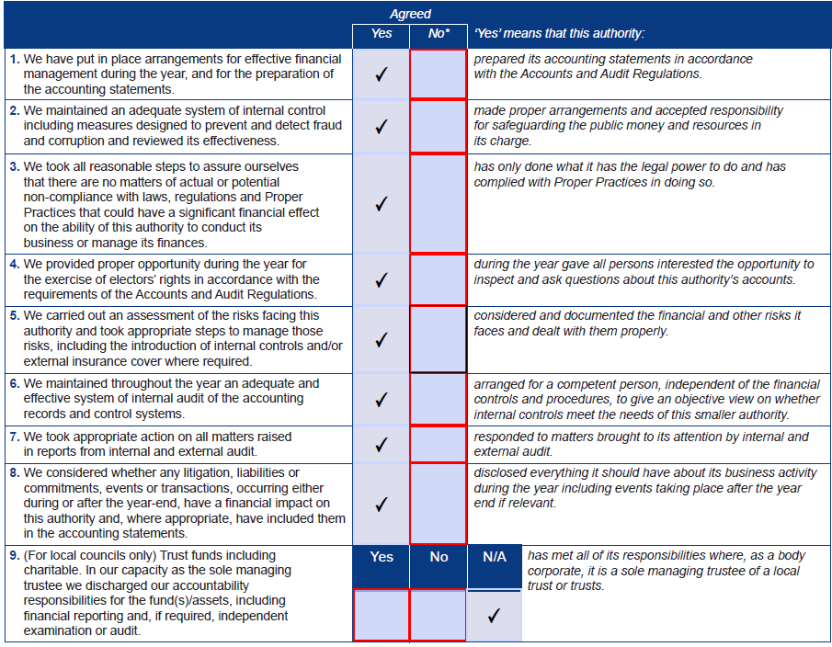
 | Statement of Accounts 2024 – 2025 Annual Return  1. Council resolved to agree the statement of accounts for the 2024 – 2025 Annual Return  2. Chair signed the statement of accounts AGAR Section 2 | AA / KK Resolv. Unanim
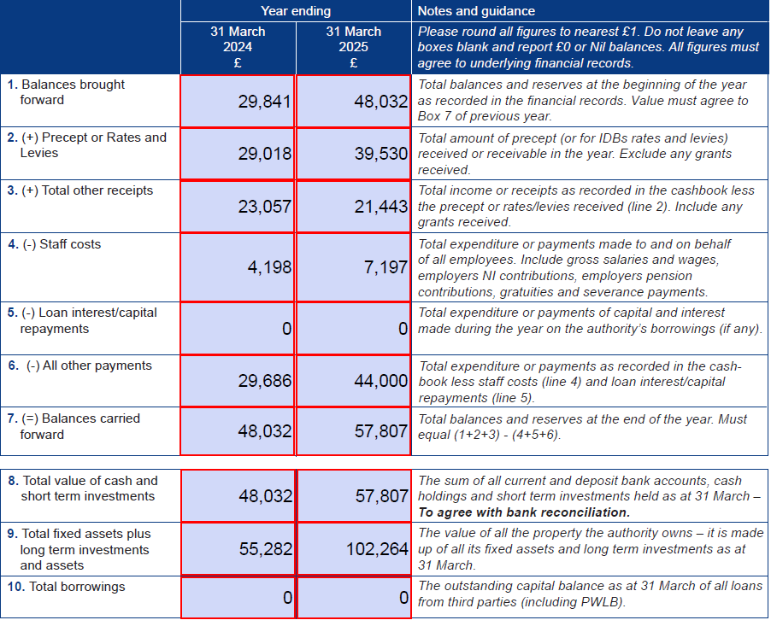
 | Explanation of Variances  - Council read aloud the variances and explanations and resolved to approve the explanation of variances to approve explanation of variance in 2024 – 2025 accounts | AA / ND Resolv. Unanim.
 | End of Month report  - Council received the End of May 2025 Financial report and:  - Noted and approved all transactions in May 2025 and  - Approved upcoming expenditure for June 2025  - Received and approved May 2025 Reconciliations of all accounts  - Chair signs reconciliations and upcoming expenditure approvals. | AA / DW: R.U  AA / DW: R.U  JF / AA: R.U,
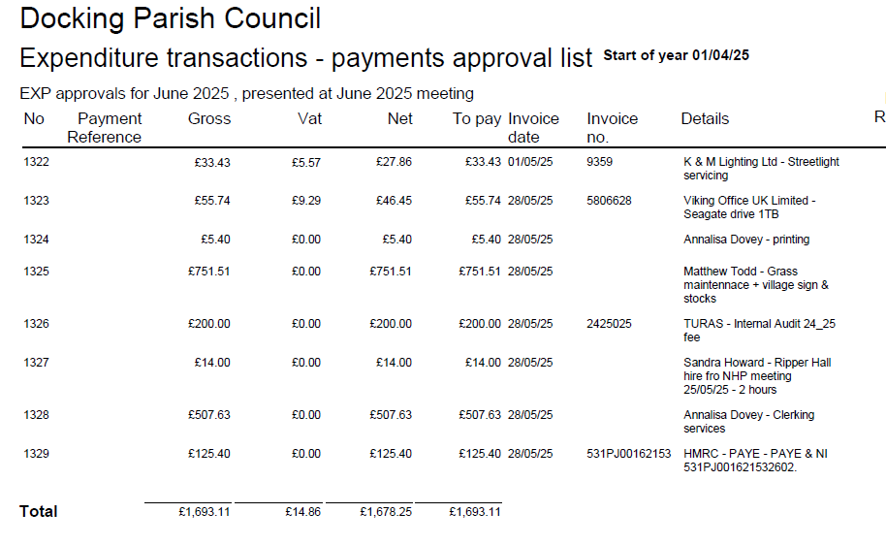
 | Insurance  1. Council heard that insurance premium has increased due to increase in asset value and insurance claim for damaged streetlight  - Council hears of the 3 quotes, Zurich would not quote due to no valuation of the Cage in the last 5 years, Gallager, the current insurer quoted ~£1900 and Clear Councils ~£1300 with no discernible different in cover.  - Council resolved to ask Gallagher if they would match the premium and then to purchase the most economical of the two.  - Action: Clerk to liaise with insurance companies and purchase cheapest quote | DW / MLe Resolv. Unanim
 | Clerks report.  - Open Projects update: Council received list of standard work and open projects, noting that to progress, some priorities need to be set, and others delayed.  - Council resolved that new projects should be brought for approval as full proposals and in line with major funding deadlines and budget setting. Instead of every month.  - Council resolved to  - Conclude ORG as a priority.  - Pause Tett Turrets  - Hand over Street furniture licenses to Cllr Archdale  - Pause Village Signage till after August.  - SAM 2 location – to proceed.  - To complete the war memorial by November  - Paus the bus seat / bench  - Pause the school parking.  - To fix wonky grass sign now  - Cllr Archdale to risk assess ponds.  - IT Arrangements  - Clerk reported that as of July 2025 RLS will no longer be in contract and tablets can be reset.  - SharePoint is no longer to be used having migrated to One drive (links already shared)  - Council has weekly (minimum) backups of data on an eternal hard drive.  - Action: Councillors to return tablets in July meeting.  - WhatsApp and working groups: Clerk noted WhatsApp groups for projects and working groups are now working and to be used for practicalities whilst and discussion must be reported transparently into council for decisions.  - SAM2 Management  - Council hear that Matthew Todd has taken on the management of the hSAM2s, charging and changing batteries and relocating.  - Council received report on data collection from SAM2s, noting difficulties of using HDMI to collect.  - Council considered options and resolved to retrofit blue tooth data collection to the SAM2 currently collecting data at a budget of £450 (+VAT) using Local Members Fund.  - Action: clerk to arrange retro fit of Bluetooth data collection to SAM2  - Council heard that Highways Licenses for street furniture ae not universally available and resolved to rectify.  - Action: clerk to send Cllr Archdale license application form and list of assets and w3w / street addresses. | Resolv. Unanim.  Resolv. Unanim.  JF /AA  Resolv. Unanim.  Resolv. Unanim.
 | Late Notices  - Ponds: Gallagher advised to do a Risk assessment on ponds and to consider signage and to keep a copy of angling club insurance on file and to check clear away with highways.  - Council confirmed highways have confirmed their responsibility for Clear aways.  - Bowls club grant application £700 for fertiliser  - Council resolved to consider in the July Meeting  - Action: Clerk to place on agenda and Cllrs to review the circulated application.  - SAM2 Location: Council heard that Mrs Hare has proposed to accept the council offered the move of the SAM2 post to the left. Council noted pre-approved to proceed.  - ORG: Council noted the correspondence from Mr & Mrs Edge re. The ORG with queries around the impact study, access road, positioning of trees, fencing.  - Cllr Durrant declares an interest and leaves the room.  - Council heard clerk has responded with current situation.  - Council agrees to include the matters raised in the already planned ORG update letter to be sent this month.  - Village website. Council confirms receipt of village website suggestion email.  - Council confirms receipt of confidential email re. Tett Turrets. | Resolv. Unanim.  Resolv. Unanim.
15 | Meeting extension.  Cllr Wroth proposed to extend the meeting by 15 minutes. Seconded by Cllr Flower | Resolv. Unanim.
 | Training  Council agrees proposition to set up joint training with Thornham after new Cllrs elected / co-opted. Action clerk to proceed wit arranging Council training. | Resolv. Unanim.
Requested Agenda items.
- Woodgate Way
  - Cllr Durant raises issue of poor maintenance of Woodgate Way, noting damaged cracked, overgrown pavements, rubbish, a traffic cone, and highways refusal to address the issue.
  - Cllr Durrant further proposes a noticeboard for Woodgate Way
    - Council briefly discusses pros and cons of having a noticeboard p there.
    - Council agrees to bring back to meeting in October for consideration of inclusion on net budget.
- Council hears proposal for a SAM2 on Station Road and briefly discusses locations and the idea.
  - Council hears that it is permissible to use existing poles if a suitable one can be found (considered by Highways on case-by -case basis)
  - Cllr Durrant agrees to collate list of all highways projects to be able to apply for funding as a collated project.
- Village Planting Cllr Durrant proposed to bring how to plant up the village nicely into project discussion for next budget.

Council noted correspondence received as follows:
- From parishioner regarding Highways works on Stanhoe Pond.
- emailed requests for NHP work.
- From Borough Council on RTS switch
  - Council agreed for clerk to place RTS in the next newsletter.
Action: Clerk to place RTS in the newsletter.
Planning Applications
None
Delegated Planning Decisions
None

Meeting dates
To confirm next meeting date: proposed: 7th July 2025
Decision required: to agree and approve next meeting date.
Agreed - all in favour
Private session
Session closed to the public under relevant legislation and standing orders. (And outcome reported in relevant section above

