DOCKING PARISH COUNCIL
Chairman: Will Pillinger ¤ Vice-Chairman: Michael Able
Hall Farm, Sedgeford Road, Docking, Kings Lynn, Norfolk, PE31 8LJ

8th July 2020
Delegated Decisions made by Docking Parish Council 21.05.20 to 03.07.20

On 18th March, a scheme of delegation was agreed by Docking Parish Council prior to lockdown. The following is a list of decisions made during Thursday 21st May and Friday 3rd July 2020. The Parish Council are now holding virtual monthly meetings which will reduce the number of decisions made by delegated decisions.

- 3rd July 2020 – Adoption of the Co-Option Policy
Decision – For adopting the policy

- 3rd July 2020 – Planning Application 20/00883/F Playing Field Pavilion
Decision – Approved

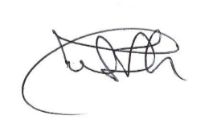
Michelle Wroth
Clerk and RFO

